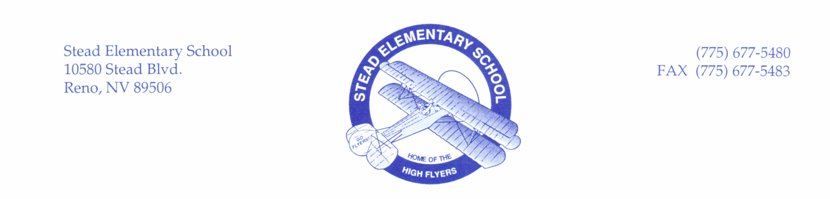

**Additional ‘Wish List Supplies’ by Grade Level**

For the 2019-2020 school year, Stead Elementary School will provide the basic school supplies for students such as paper, pencils, folders, notebooks, glue sticks, scissors, highlighters, wire bound notebooks, ball point pens, colored pencils, markers, and crayons through Title I funds.

Below are grade level ‘wish’ lists for families who want to contribute supplies. $10 is also appreciated to help cover class projects, art, holiday projects, and other classroom projects for each student (check made payable to Stead Elementary or cash is great). If you have any questions, please call us at 775-677-5480.

**Kindergarten**

* Baby wipes
* Lysol cleaning wipes
* Quart size baggies
* Gallon size baggies
* Extra Dry erase markers (Expo)
* Extra Tissue (soft for little noses)
* Extra glue sticks
* $10 for classroom supplies and projects

**Second Grade**

* 2 pencil packs/ pencil sharpener
* Erasers
* 10 glue sticks
* Clorox Wipes
* $10 for classroom supplies and projects

**First Grade**

* Gallon size baggies
* Sandwich size baggies
* Clorox wipes
* Large pink erasers
* Soft Kleenex
* Bottled glue
* $10 for classroom supplies and projects

**Fifth Grade**

* Composition Notebooks
* Pint/snack size baggies
* Fine tip Crayola markers
* Dry erase markers
* Clorox Wipes
* $10 for classroom supplies and projects

**Fourth Grade**

* Extra Erasers – pink & pencil top
* Glue Sticks
* Protractors
* Pencil box
* Extra Dry erase markers (Expo)
* $10 for classroom supplies and projects

**Third Grade**

* Clorox wipes
* Kleenex
* Extra Erasers – pink & pencil top
* Extra Dry erase markers (Expo)
* $10 for classroom supplies and projects

|  |  |
| --- | --- |
| **6th Grade Supplies** | |
| Ruler | Calculator |
| Markers | Flash Drive |
| Dry erase markers | Clorox Wipes |
| Composition Notebooks | Hand Sanitizer |
| $10 for classroom supplies and projects | |